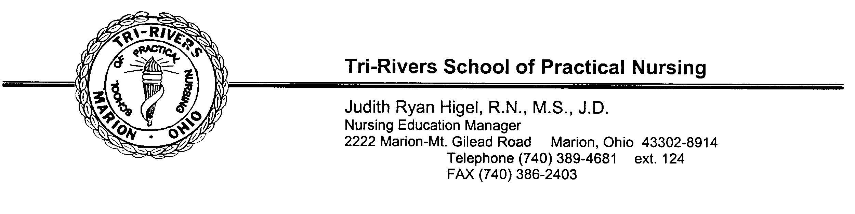
Emeline Kelly, DNP, MSN, ACNS-BC, RN
Director of Health Care Education and Public Safety Service Programs
2222 Marion-Mt. Gilead Rd.
Marion, OH 43302
Phone (740) 389-4682, ext. 5514
Fax (740) 389-4683

Dear Prospective Student:

Thank you for your inquiry regarding our Practical Nursing program. In recent years, we have had numerous requests from students to apply for our program. While there are several steps involved in the application/admissions process, we have tried to streamline the information to make it easier for you.

The first step in our application process is to complete the enclosed application form and submit the $95 non-refundable application fee along with a letter of admission. Once you have paid the application fee you are eligible to sit for the required pre-entrance exams WorkKeys® tests. Checks or money orders for the application fee should be made payable to Tri-Rivers Adult Education.

An official high school transcript is also required and enclosed is a form that can be used to request that your high school transcript be sent to our school.

Because enrollment is limited and our class fills up rapidly each year, we encourage you not to delay in completing this information and the other steps in the application process.
For further information, please call Suzy Wall (740) 389-4682 x 5526.
Sincerely,

Emeline Kelly, DNP, MSN, ACNS-BC, RN
Director of Health Care Education and Public Safety Service Programs

Enclosures

LICENSED PRACTICAL NURSING

Nature of the Work
Licensed practical nurses (LPNs), or licensed vocational nurses (LVNs), care for the sick, injured, convalescent, and disabled under the direction of physicians and registered nurses.

Most LPNs provide basic bedside care, taking vital signs such as temperature, blood pressure, pulse, and respiration. They also prepare and give injections and enemas, monitor catheters, apply dressings, treat bedsores, and give alcohol rubs and massage s. LPNs monitor their patients and report adverse reactions to medications or treatments. They collect samples for testing, perform routine laboratory tests, feed patients, and record food and fluid intake and output. To help keep patients comfortable, LPN s assist with bathing, dressing, and personal hygiene. In States where the law allows, they may administer prescribed medicines or start intravenous fluids. Some LPNs help deliver, care for, and feed infants. Experienced LPNs may supervise nursing assistants and aides.

In addition to providing routine bedside care, LPNs in nursing care facilities help evaluate residents’ needs, develop care plan s, and supervise the care provided by nursing aides. In doctors’ offices and clinics, they also may make appointments, keep records, and perform other clerical duties. LPNs who work in private homes may prepare meals and teach family members simple nursing tasks.

Working Conditions
Most licensed practical nurses in hospitals and nursing care facilities work a 40-hour week, but because patients need around-the- clock care, some work nights, weekends, and holidays. They often stand for long periods and help patients move in bed, stand, or walk.

LPNs may face hazards from caustic chemicals, radiation, and infectious diseases such as hepatitis. They are subject to back injuries when moving patients and shock from electrical equipment. They often must deal with the stress of heavy workloads. In addit ion, the patients they care for may be confused, irrational, agitated, or uncooperative.

Employment
Licensed practical nurses held about 702,000 jobs in 2002. About 28 percent of LPNs worked in hospitals, 26 percent in nursi ng care
facilities, and another 12 percent in offices of physicians. Others worked for home healthcare services, employment services, community care facilities for the elderly, public and private educational services, outpatient care centers, and Federal, State, and local government agencies; about 1 in 5 worked part time.

Job Outlook
Employment of LPNs is expected to grow about as fast as the average for all occupations through 2012 in response to the long-term care needs of an increasing elderly population and the general growth of healthcare. Replacement needs will be a major source of job openings.

Applicants for jobs in hospitals may face competition as the number of hospital jobs for LPNs declines in acute care settings. An increasing proportion of sophisticated procedures, which once were performed only in hospitals, is being performed in physici ans’ offices and in outpatient care centers such as ambulatory surgical and emergency medical centers, due largely to advance in technology. Consequently, employment of LPNs is projected to grow faster than average in these sectors as healthcare expands outside the traditional hospital setting.

Employment of LPNs in nursing care facilities is expected to grow faster than the average. Such facilities will offer the most new jobs for LPNs as the number of aged and disabled persons in need of long-term care rises. In addition to caring for the aged and the disabled, LPNs in nursing care facilities will care for the increasing number of patients who will have been discharged from the hospital, but have not recovered enough to return home.

Employment of LPNs is expected to grow much faster than average in home healthcare services. This growth is in response to an increasing number of older persons with functional disabilities, consumer preference for care in the home, and technological advances that make it possible to bring increasingly complex treatments into the home.

Earnings
Median annual earning of licensed practical nurses were $31,440 in 2002. The middle 50 percent earned between $26,430 and
$37,050. The lowest 10 percent earned less than $22,860, and the highest 10 percent earned more than $44,040. Median annual earning in the industries employing the largest numbers of licensed practical nurses in 2002 were as follows:

Employment services | $40,550 | Home health care services | $32,850
Nursing care facilities | 32,220 | General medical and surgical hospitals | 30,310
Offices of physicians | 28,710

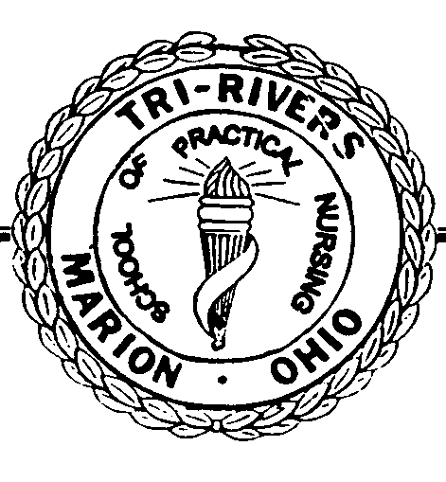
PN PROGRAM EXPENSES

***ALL FEES SUBJECT TO CHANGE***

COSTS DUE TO THE SCHOOL *Non-refundable fee

*Application Fee | Includes initial pre-entrance WorkKeys® testing | $95
*Pre-entrance WorkKeys® testing retakes | If applicable | $15 per test
*Admission Fee | Due upon acceptance into program | $500
*Lab Fee | Due 1st day of class | $200
*Technology Fee | $195 per quarter (includes ATI, LMS, C/Wide Wi-Fi, Support) | $780

Practical Nursing Tuition
$3,025.00 per quarter | x 4 quarters | $12,100

Total Tuition & Fees
Includes Tuition x 4 quarters, Application Fee, Admission Fee, Lab Fee & Technology Fee  (Each quarter’s tuition is due BEFORE the first day of the quarter. Applicants are encouraged to begin saving for their education and financially planning before admission to the program.) | $13,675.00

Pre-Requisite Classes
CPR | CPR Certification must be either American Red Cross Professional Rescuer or American Heart Association Healthcare Provider.
Nurse Aide | CPR is part of our Tri-Rivers Nurse Aide curriculum. There is no discount given if you already have CPR. Does not include STNA testing fee. | $665
Learning Strategies | Required course through Tri-Rivers Career Center. | $204
Medical Terminology | Textbook included in cost of class. | $386
Math for Meds | Textbook included in cost of class. | $314
TRCC ComTech | Required course through Tri-Rivers Career Center. | $154

OTHER ESTIMATED PROGRAM COSTS PAID BY THE STUDENT

Textbooks (estimated) based on 2019-20 | $1,287.00 | Stethoscope | $35.00
BCI/FBI Background Check | $60.00 | Paper Supplies | $100.00
Physical Exam (call nursing office for info) | $441.00 | State Board Application Fee | $275.00
2 Uniforms/Lab Coat | $140.00 | Meals (estimated) | $965.00
Bandage Scissors | $10.00 | Mileage (average) | $5,638.00
Shoes/Hosiery | $125.00 | Total Estimated Costs | $9,111.00
Watch | $35.00

Unless a double payment has inadvertently been made, no refund will be issued to a student without the student first submitting a request in writing to the director explaining the extenuating circumstances and proof wherever possible. Any refunds that are ultimately issued may take two weeks to process.
Note: These costs are subject to change. Please check with the school for updated cost information.

PN Costs 2020-2021/Revision Date: 01/2020
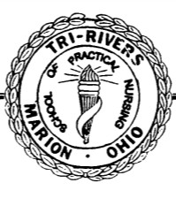

2222 Marion-Mt. Gilead Road Phone: (740) 389-4682
Marion, OH 43302 Fax: (740) 389-4683

Rules and Regulations
Criteria for Admission to Tri-Rivers School of Practical Nursing

No person is excluded on the grounds of race, color, creed, gender, national origin, marital status or disability.

Academic Achievement - Applicants must be graduates of an accredited high school or provide evidence of established equivalency of high school through the General Education Development Test (G.E.D.).
* A high school transcript or official report of G. E .D. test results is required.
* Applicants should have satisfactorily completed at least one course in science. Biology is recommended.
* A satisfactory grade in Math is required. Algebra is recommended.
* Previous college credits will be evaluated on an individual basis.

General Ability
- Pass WorkKeys® testing at a level 4 in each of the following tests: Workplace Documents, Applied Math and Graphic Literacy

Personality and Interest – An interview with the Nursing Director or designee is required.
* The manager recommends admission based on the applicant's realistic knowledge of practical nursing, personal motivation, attitude, and maturity.
* Another member of the faculty may be asked to conduct a second interview if the nursing education manager has identified a need.

Admission Pre-requisites
1) Successful completion of a Nurse Aide course within the last three years
2) A mandatory Math for Meds class
3) A mandatory Learning Strategies for Health Care Professionals class. (9/99)
4) A mandatory Medical Terminology class (2/01)
5) A mandatory Nursing ComTech Tri-Rivers Course (1/04)
6) Current CPR card through American Red Cross Professional Rescuer or American Heart Association
Healthcare Provider. (CPR training is included as part of Tri-Rivers Nurse Aide Course)
7) PN Class Orientation

Applicants must receive a satisfactory (S) grade for all prerequisite classes before admission to the nursing class.

Physical Examination
A. Prior to final acceptance, admitted applicants are required to have a physical examination. The School of Practical Nursing provides the examination form. Final admission into the program is contingent upon the physical exam. The individual must be able to meet all the program's requirements, despite any handicaps.
• The Rehabilitation Act of 1973 prohibits all programs and activities receiving federal funding from discriminating against any
"otherwise qualified disabled individual."
• In order to be in compliance with the American Disability Act, the following is a list of essential functions for prospective students who wish to pursue a nursing education:
• Students need to be aware that the nursing profession requires physical requirements necessary to safely and accurately carry out nursing duties.
• Manual dexterity required for preparing and administering medications, physical ability to transfer patients, ability to read medication labels and patient records, hear blood pressure and breath sounds through a stethoscope (specific types are available), speak English clearly enough for most patients to understand, and understand the verbal communication of English speaking clients.
Admission Acceptance Regulation
A. Applicants will be notified of the Admission Committee’s decision.
B. To accept admission, a letter of acceptance and payment of the current admission fee must be submitted to the school within one month. (In the event that admission occurs near the starting date, a shorter period of time may be indicated.)

2222 Marion-Mt. Gilead Road Phone: (740) 389-4682
Marion, OH 43302 Fax: (740) 389-4683

Practical Nursing Timeline – Checklist

- Submit application, $95 application fee and Request for Admission Letter:
  - Addressed to: Nursing Admissions Committee
Tri-Rivers Center for Adult Education
2222 Marion-Mt. Gilead Rd.
Marion, OH 43302
  - The letter must include:
          - A brief introduction of yourself, your professional background, and for which program you are applying
          - Why do you want to be a nurse?
          - Why are you interested in the Tri-Rivers nursing program?
          - What are your career goals and how does the Tri-Rivers nursing program facilitate those goals?
          - What characteristics or strengths do you possess that will help you be successful in the Tri-Rivers nursing program?
          - How will you maintain balance with school, work and home responsibilities?
          - What is your plan and timeline for completion of any outstanding pre-requisites by the start of the program?
          - Why should we consider you for admission to the nursing program?

- Submit an official high school and college transcripts.
- Contact the Adult Education office at 740-389-4682 ext. 5500 to sign up for and complete entrance testing of the WorkKeys® tests.
- Complete the following pre-requisites:
  - Proof of State Tested Nurse Aide, or proof of successful completion of Nurse Aide class within 3 years, or employer statement with proof of 12 months of full time employment as a nurse aide or orderly within the last 3 years.
  - CPR certification - Acceptable class titles include: American Red Cross “CPR for the Professional Rescuer” (good for 1 year) or American Heart Association: “CPR for the Healthcare Provider” (good for 2 years).
  - Math for Meds Class
  - Medical Terminology Class
  - Learning Strategies Class
  - Tri-Rivers Nursing ComTech Class
- Interview with Program Director – After submitting your application and application fee, you will be contacted to schedule an interview with the Director or faculty member. After your interview, a letter will be mailed out to those individuals who have been accepted into the Practical Nursing Program.
- Secure financial aid for tuition. Contact Nikki Hamilton at 740-389-4682 ext. 5524
- Submit $500 admission fee upon acceptance.
- Attend the Program Orientation on June 4, 2021
- Classes start August 09, 2021.
***You will receive additional information at the Program Orientation***

STUDENT INSTRUCTIONS:
1) Complete this form.

2222 Marion-Mt. Gilead Rd.
Marion, OH 43302

TRANSCRIPT REQUEST
Phone: 740-389-4682
Fax: 740-389-4683
Please return a copy of this form with your transcript.

2) Take it or mail it to the high school/college/university you are requesting a transcript from.
They will forward the transcript to Tri-Rivers Center for Adult Education.

Please check the program you are applying for: Practical Nursing LPN to RN Transition Program Patient Care Technician

Name Social Security #
First Last Maiden

Are any of your educational or employment records in another name? If so, identify:

Address City

State Zip Code

Telephone ( ) E-mail

High School or College Attended

Address City State Zip

Date graduated Will graduate Withdrew I hereby authorize the above named school to release the appropriate records to:

Tri-Rivers Center for Adult Education
Attn: Suzy Wall, Nursing Department
2222 Marion-Mt. Gilead Road
Marion, OH 43302

Student Signature Date

G Transcript Request 12-13-14 Page 1 of 1 Revision Date: 1/2020

